Ejemplo de orden con las colecciones adicionales:
Orden 0000098601

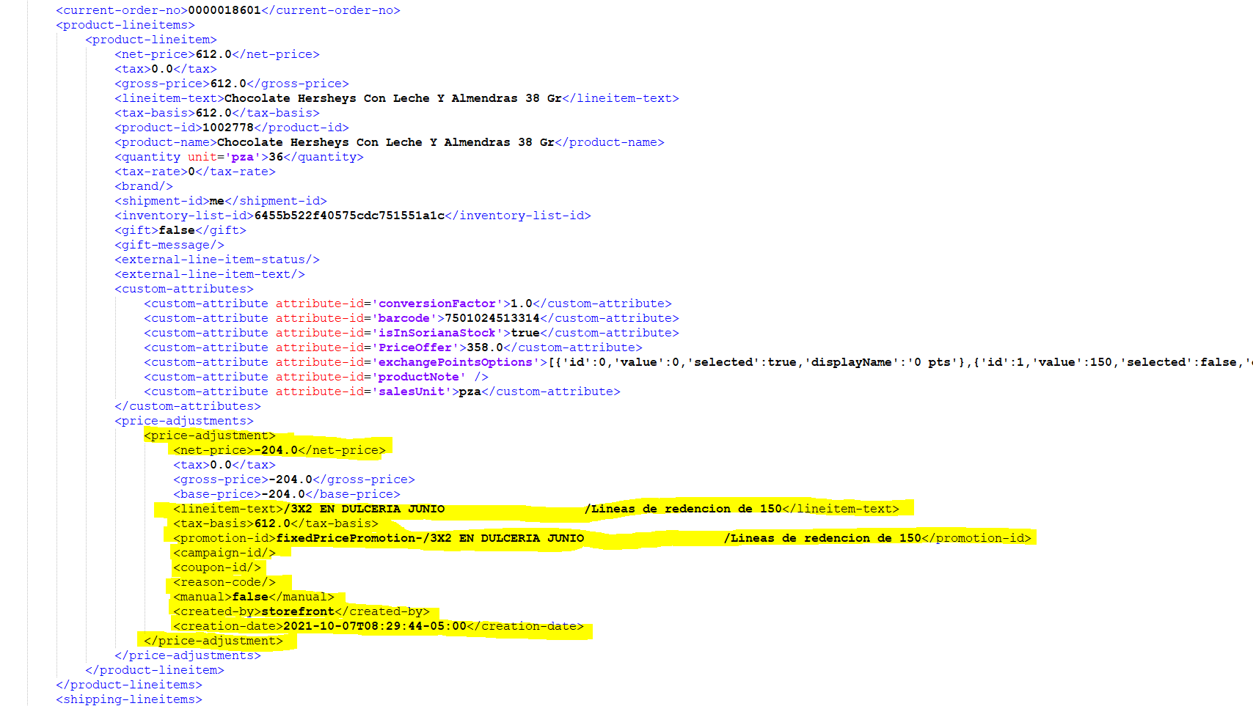

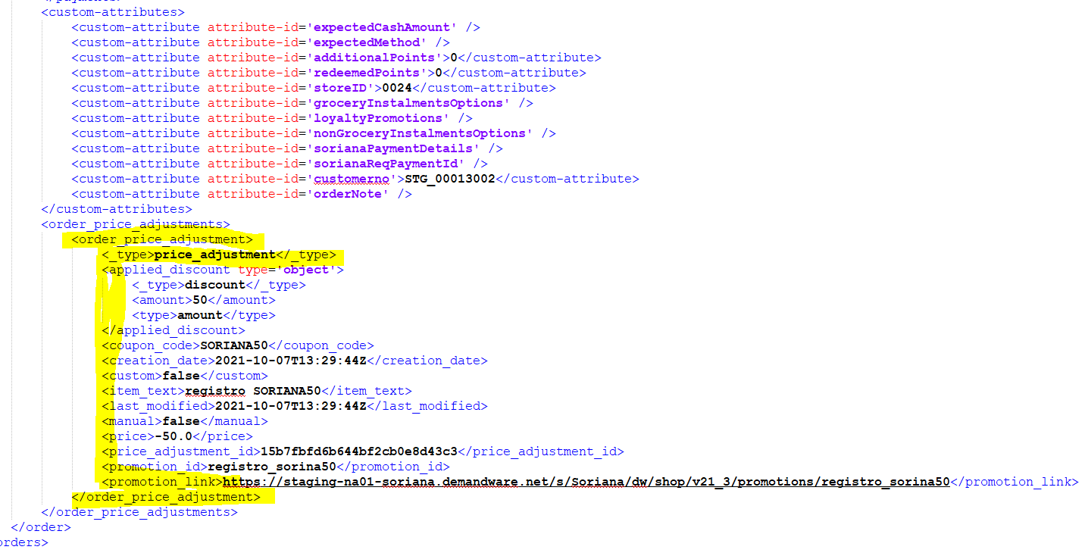

Tablas creadas en MercurioQaDB:
- dbo.OrderFacts_UE_PriceAdjOrder
Una orden puede tener varios cupones asignados
Esta tabla recibe la estructura <order_price_adjustments>

- dbo.OrderFacts_UE_PriceAdjItems
Un producto puede tener varias promociones aplicadas
Esta tabla recibe la estructura <price_adjustments> de los artículos.

Estructuras:

SET ANSI_NULLS ON
GO
SET QUOTED_IDENTIFIER ON
GO

CREATE TABLE [dbo].[OrderFacts_UE_PriceAdjOrder](
[OrderNo] [int] NOT NULL,
[UeNo] [varchar](25) NOT NULL,
[CnscOrder] [bigint] NOT NULL,
[type] [varchar](100) NULL,
[couponCode] [varchar](100) NULL,
[creationDate] [datetime] NULL,
[custom] [bit] NULL,
[itemText] [varchar](255) NULL,
[lastModified] [datetime] NULL,
[manual] [bit] NULL,
[price] [money] NULL,
[priceAdjustmentId] [varchar](100) NULL,
[promotionId] [varchar](255) NULL,
[promotionLink] [varchar](1000) NULL,
CONSTRAINT [PK_OrderFacts_UE_PriceAdjOrder] PRIMARY KEY NONCLUSTERED
(
[OrderNo] ASC,
[UeNo] ASC,
[CnscOrder] ASC
)WITH (STATISTICS_NORECOMPUTE = OFF, IGNORE_DUP_KEY = OFF, OPTIMIZE_FOR_SEQUENTIAL_KEY = OFF) ON [PRIMARY]
) ON [PRIMARY]
GO

SET ANSI_NULLS ON
GO
SET QUOTED_IDENTIFIER ON
GO

CREATE TABLE [dbo].[OrderFacts_UE_PriceAdjItems](
[OrderNo] [int] NOT NULL,
[UeNo] [varchar](25) NOT NULL,
[CnscOrder] [bigint] NOT NULL,
[ProductId] [int] NOT NULL,
[Barcode] [bigint] NOT NULL,
[ItemCnsc] [int] NOT NULL,
[type] [varchar](100) NULL,
[createdBy] [varchar](100) NULL,
[creationDate] [datetime] NULL,
[custom] [bit] NULL,
[itemText] [varchar](255) NULL,
[lastModified] [datetime] NULL,
[manual] [bit] NULL,
[price] [money] NULL,
[priceAdjustmentId] [varchar](100) NULL,
[promotionId] [varchar](255) NULL,
[promotionLink] [varchar](1000) NULL,
[isSorianaPromo] [bit] NULL,
CONSTRAINT [PK_OrderFacts_UE_PriceAdjItems] PRIMARY KEY NONCLUSTERED
(
[OrderNo] ASC,
[UeNo] ASC,
[CnscOrder] ASC,
[ProductId] ASC,
[Barcode] ASC,
[ItemCnsc] ASC
)WITH (STATISTICS_NORECOMPUTE = OFF, IGNORE_DUP_KEY = OFF, OPTIMIZE_FOR_SEQUENTIAL_KEY = OFF) ON [PRIMARY]
) ON [PRIMARY]
GO

{
"_type": "order",
"adjusted_merchandize_total_tax": -0.4,
"adjusted_shipping_total_tax": 5.24,
"billing_address": {
"_type": "order_address",
"address1": "Av. Triunfador",
"city": "Monterrey",
"company_name": " ",
"country_code": "MX",
"first_name": "Marce",
"full_name": "Marce Rosales",
"id": "34a1c030acea081caaa1817c54",
"last_name": "Rosales",
"postal_code": "64209",
"state_code": "Nuevo León",
"c_buildingNumber": "123",
"c_colonia": "Tierra Propia (F-35)",
"c_streetNumber": "123"
},
"confirmation_status": "confirmed",
"coupon_items": [
{
"_type": "coupon_item",
"code": "SORIANA50",
"coupon_item_id": "955dff724eedb99e9a390e1d1f",
"status_code": "applied",
"valid": true
}
],
"created_by": "Customer",
"creation_date": "2021-10-07T13:29:44Z",
"currency": "MXN",
"customer_info": {
"_type": "customer_info",
"customer_id": "abPVt9ZdYsELTjH1JlrOdWhVaR",
"customer_name": "Marce Rosales",
"customer_no": "STG_00013002",
"email": "josera@soriana.com"
},
"customer_name": "Marce Rosales",
"export_status": "ready",
"last_modified": "2021-10-07T13:30:04Z",
"merchandize_total_tax": 0.0,
"notes": {
"_type": "simple_link",
"link": "https://staging-na01-soriana.demandware.net/s/Soriana/dw/shop/v21_3/orders/0000018601/notes"
},
"order_no": "0000018601",
"order_price_adjustments": [
{
"_type": "price_adjustment",
"applied_discount": {
"_type": "discount",
"amount": 50,
"type": "amount"
},
"coupon_code": "SORIANA50",
"creation_date": "2021-10-07T13:29:44Z",
"custom": false,
"item_text": "registro SORIANA50",
"last_modified": "2021-10-07T13:29:44Z",
"manual": false,
"price": -50.0,
"price_adjustment_id": "15b7fbfd6b644bf2cb0e8d43c3",
"promotion_id": "registro_sorina50",
"promotion_link": "https://staging-na01-soriana.demandware.net/s/Soriana/dw/shop/v21_3/promotions/registro_sorina50"
}
],
"order_token": "kgvMlxW3AEwJ1SILklarY1Sp7fNEKnH90dlGlFSHmj8",
"order_total": 396.0,
"payment_instruments": [
{
"_type": "order_payment_instrument",
"amount": 396.0,
"payment_card": {
"_type": "payment_card",
"card_type": "Visa",
"credit_card_expired": false,
"credit_card_token": "7010000000093121111-C9CB98B8EC6095FAE053AF598E0A65CF",
"masked_number": "***************1111",
"number_last_digits": "1111"
},
"payment_instrument_id": "e6887f369d4f3118ae925f3884",
"payment_method_id": "CREDIT_CARD",
"c_bankIDnumber": "411111",
"c_cardIcon": " https://production-na01-soriana.demandware.net/on/demandware.static/-/Library-Sites-SorianaSharedLib/default/images/carriers/visa@2x.png",
"c_storedPaymentUUID": "f7bdc4b0-c5ae-4a17-8f02-cf0401f8122f"
}
],
"payment_status": "paid",
"product_items": [
{
"_type": "product_item",
"adjusted_tax": 0.0,
"base_price": 17.0,
"bonus_product_line_item": false,
"gift": false,
"inventory_id": "0024-inventory",
"item_id": "6455b522f40575cdc751551a1c",
"item_text": "Chocolate Hersheys Con Leche Y Almendras 38 Gr",
"price": 612.0,
"price_adjustments": [
{
"_type": "price_adjustment",
"created_by": "storefront",
"creation_date": "2021-10-07T13:29:44Z",
"custom": true,
"item_text": "/3X2 EN DULCERIA JUNIO /Lineas de redencion de 150 ",
"last_modified": "2021-10-07T13:29:44Z",
"manual": false,
"price": -204.0,
"price_adjustment_id": "8a1c10416eaf6fb6c45f3c9da1",
"promotion_id": "fixedPricePromotion-/3X2 EN DULCERIA JUNIO /Lineas de redencion de 150 ",
"c_isSorianaPromo": true
}
],
"price_after_item_discount": 408.0,
"price_after_order_discount": 358.0,
"product_id": "1002778",
"product_name": "Chocolate Hersheys Con Leche Y Almendras 38 Gr",
"quantity": 36,
"shipment_id": "me",
"tax": 0.0,
"tax_basis": 612.0,
"tax_class_id": "NoTax",
"tax_rate": 0,
"c_barcode": "7501024513314",
"c_conversionFactor": 1.0,
"c_exchangePointsOptions": "[{\"id\":0,\"value\":0,\"selected\":true,\"displayName\":\"0 pts\"},{\"id\":1,\"value\":150,\"selected\":false,\"displayName\":\"150 pts\",\"newPrice\":11.3333},{\"id\":2,\"value\":300,\"selected\":false,\"displayName\":\"300 pts\",\"newPrice\":22.6666},{\"id\":3,\"value\":450,\"selected\":false,\"displayName\":\"450 pts\",\"newPrice\":33.9999},{\"id\":4,\"value\":600,\"selected\":false,\"displayName\":\"600 pts\",\"newPrice\":45.3332},{\"id\":5,\"value\":750,\"selected\":false,\"displayName\":\"750 pts\",\"newPrice\":56.6665},{\"id\":6,\"value\":900,\"selected\":false,\"displayName\":\"900 pts\",\"newPrice\":67.9998},{\"id\":7,\"value\":1050,\"selected\":false,\"displayName\":\"1,050 pts\",\"newPrice\":79.3331},{\"id\":8,\"value\":1200,\"selected\":false,\"displayName\":\"1,200 pts\",\"newPrice\":90.6664},{\"id\":9,\"value\":1350,\"selected\":false,\"displayName\":\"1,350 pts\",\"newPrice\":101.99969999999999},{\"id\":10,\"value\":1500,\"selected\":false,\"displayName\":\"1,500 pts\",\"newPrice\":113.333},{\"id\":11,\"value\":1650,\"selected\":false,\"displayName\":\"1,650 pts\",\"newPrice\":124.66629999999999},{\"id\":12,\"value\":1800,\"selected\":false,\"displayName\":\"1,800 pts\",\"newPrice\":135.9996},{\"id\":13,\"value\":1950,\"selected\":false,\"displayName\":\"1,950 pts\",\"newPrice\":147.3329},{\"id\":14,\"value\":2100,\"selected\":false,\"displayName\":\"2,100 pts\",\"newPrice\":158.6662},{\"id\":15,\"value\":2250,\"selected\":false,\"displayName\":\"2,250 pts\",\"newPrice\":169.99949999999998},{\"id\":16,\"value\":2400,\"selected\":false,\"displayName\":\"2,400 pts\",\"newPrice\":181.3328},{\"id\":17,\"value\":2550,\"selected\":false,\"displayName\":\"2,550 pts\",\"newPrice\":192.6661},{\"id\":18,\"value\":2700,\"selected\":false,\"displayName\":\"2,700 pts\",\"newPrice\":203.99939999999998},{\"id\":19,\"value\":2850,\"selected\":false,\"displayName\":\"2,850 pts\",\"newPrice\":215.3327},{\"id\":20,\"value\":3000,\"selected\":false,\"displayName\":\"3,000 pts\",\"newPrice\":226.666},{\"id\":21,\"value\":3150,\"selected\":false,\"displayName\":\"3,150 pts\",\"newPrice\":237.99929999999998},{\"id\":22,\"value\":3300,\"selected\":false,\"displayName\":\"3,300 pts\",\"newPrice\":249.33259999999999},{\"id\":23,\"value\":3450,\"selected\":false,\"displayName\":\"3,450 pts\",\"newPrice\":260.66589999999997},{\"id\":24,\"value\":3600,\"selected\":false,\"displayName\":\"3,600 pts\",\"newPrice\":271.9992},{\"id\":25,\"value\":3750,\"selected\":false,\"displayName\":\"3,750 pts\",\"newPrice\":283.3325},{\"id\":26,\"value\":3900,\"selected\":false,\"displayName\":\"3,900 pts\",\"newPrice\":294.6658},{\"id\":27,\"value\":4050,\"selected\":false,\"displayName\":\"4,050 pts\",\"newPrice\":305.9991},{\"id\":28,\"value\":4200,\"selected\":false,\"displayName\":\"4,200 pts\",\"newPrice\":317.3324},{\"id\":29,\"value\":4350,\"selected\":false,\"displayName\":\"4,350 pts\",\"newPrice\":328.66569999999996},{\"id\":30,\"value\":4500,\"selected\":false,\"displayName\":\"4,500 pts\",\"newPrice\":339.99899999999997},{\"id\":31,\"value\":4650,\"selected\":false,\"displayName\":\"4,650 pts\",\"newPrice\":351.3323},{\"id\":32,\"value\":4800,\"selected\":false,\"displayName\":\"4,800 pts\",\"newPrice\":362.6656},{\"id\":33,\"value\":4950,\"selected\":false,\"displayName\":\"4,950 pts\",\"newPrice\":373.9989},{\"id\":34,\"value\":5100,\"selected\":false,\"displayName\":\"5,100 pts\",\"newPrice\":385.3322},{\"id\":35,\"value\":5250,\"selected\":false,\"displayName\":\"5,250 pts\",\"newPrice\":396.6655},{\"id\":36,\"value\":5400,\"selected\":false,\"displayName\":\"5,400 pts\",\"newPrice\":407.99879999999996}]",
"c_fixedPrice": "11.3333",
"c_fixedPricePromoName": "/3X2 EN DULCERIA JUNIO /Lineas de redencion de 150 ",
"c_fromStoreId": "0024",
"c_isInSorianaStock": true,
"c_salesUnit": "pza",
"c_selectedUnit": "pza"
}
],
"product_sub_total": 408.0,
"product_total": 358.0,
"shipments": [
{
"_type": "shipment",
"adjusted_merchandize_total_tax": 0.0,
"adjusted_shipping_total_tax": 5.24,
"gift": false,
"merchandize_total_tax": 0.0,
"product_sub_total": 408.0,
"product_total": 358.0,
"shipment_id": "me",
"shipment_no": "00073501",
"shipment_total": 446.0,
"shipping_address": {
"_type": "order_address",
"address1": "Av. Triunfador",
"address2": "Tierra Propia (F-35)",
"city": "Monterrey",
"country_code": "MX",
"first_name": "Jose",
"full_name": "Jose",
"id": "4ea20c42fece4755a159f4281e",
"phone": "123 456 7890",
"postal_code": "64209",
"state_code": "Nuevo León",
"c_RFC": " ",
"c_buildingNumber": "123",
"c_colonia": "Tierra Propia (F-35)",
"c_geolocation": " ",
"c_reference": "Azul",
"c_streetNumber": "123"
},
"shipping_method": {
"_type": "shipping_method",
"id": "homeDelivery",
"name": "Envío a domicilio",
"c_storePickupEnabled": false
},
"shipping_status": "not_shipped",
"shipping_total": 38.0,
"shipping_total_tax": 5.24,
"tax_total": 5.24,
"c_applicableShippingMethods": "[{\"shippingMethodID\":\"homeDelivery\",\"shippingCost\":\"38.0000\"},{\"shippingMethodID\":\"pickup\",\"shippingCost\":\"0.00\"}]",
"c_displayIndex": 0,
"c_displayName": "Super en tu casa",
"c_isSelectedByUser": true,
"c_shipmentId": "001-1",
"c_shipmentType": "grocery",
"c_shippingPrice": 38.0,
"c_slotDateTime": "2021-10-07 11:00",
"c_slotDay": "Hoy",
"c_slotName": "de 11 a 12",
"c_slotSelectionTimestamp": "2021-10-07T13:28:22Z"
}
],
"shipping_items": [
{
"_type": "shipping_item",
"adjusted_tax": 5.24,
"base_price": 38.0,
"item_id": "ad6aebe76c0a1334342c53b448",
"item_text": "Shipping",
"price": 38.0,
"price_after_item_discount": 38.0,
"shipment_id": "me",
"tax": 5.24,
"tax_basis": 38.0,
"tax_class_id": "IVA",
"tax_rate": 0.16
}
],
"shipping_status": "not_shipped",
"shipping_total": 38.0,
"shipping_total_tax": 5.24,
"site_id": "Soriana",
"status": "new",
"taxation": "gross",
"tax_total": 4.84,
"c_additionalPoints": 51.0,
"c_basketUUID": "a28ca4fde369971a7b92de5dd4",
"c_discountPlanID": "C13629F2-E1A7-462C-8AEA-C80272EBF293",
"c_earnedMoney": 0.0,
"c_loyaltyPromotions": "{\"cash\":{\"value\":49407,\"formatted\":\"$49,407.00\"},\"electronicmoney\":{\"value\":48221,\"formatted\":\"$48,221.00\"},\"puntos\":{\"value\":111,\"formatted\":\"111 pts\",\"usedPoints\":{\"2cd24a016b6944ff98ac0b399c\":{\"points\":0,\"price\":0}}},\"appliedTotalPuntos\":0}",
"c_redeemedPoints": 0.0,
"c_salesChannel": "web",
"c_sorianaPaymentDetails": "{\"storeID\":\"0024\",\"receiptBarCode\":\"\",\"isPending\":false,\"customerLoyaltyRedeemMoney\":\"0\",\"customerLoyaltyRedeemElectronicMoney\":\"0\",\"customerLoyaltyRedeemPoints\":\"0\"}",
"c_sorianaReqPaymentId": "21c73937-465b-4dc5-bdd2-8b3a6a96fc0a",
"c_storeID": "0024"
}

